Extended Data Figures & Captions

Figure 1.

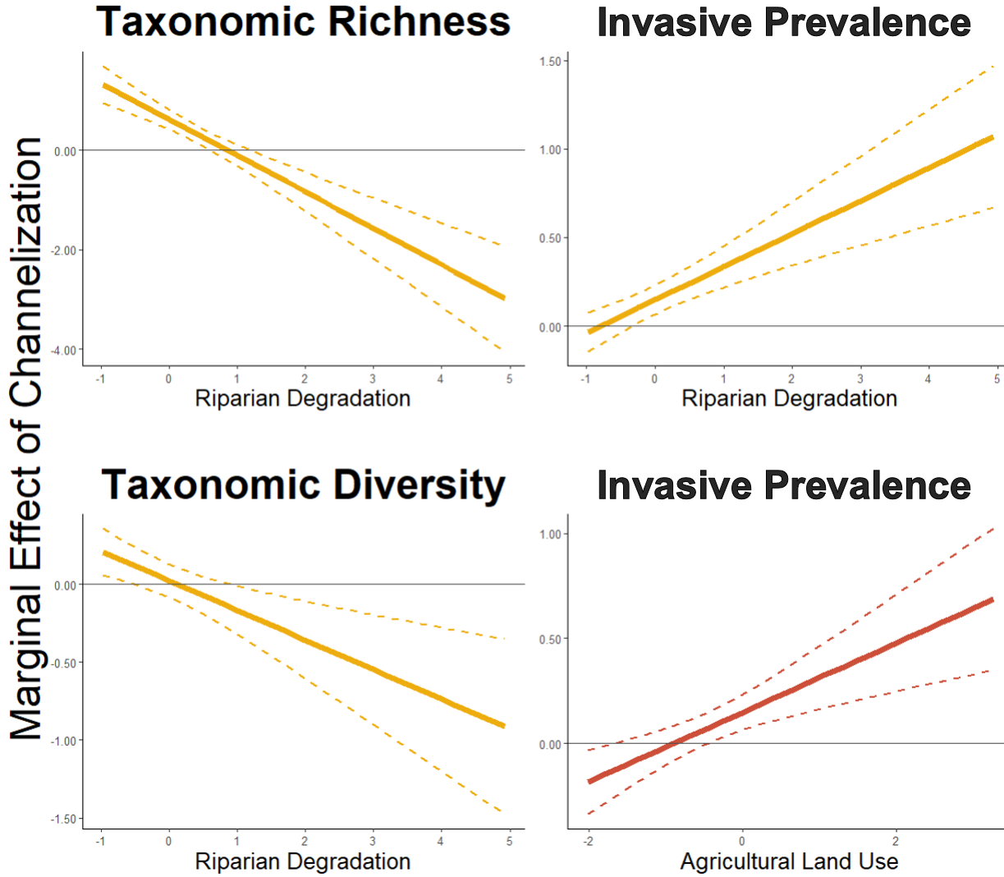

**Figure 1.** Macroinvertebrate’s response to channelization is dependent on riparian degradation and agricultural cover. The panels show the marginal effect of channelization from the GLMMs on macroinvertebrate communities along a gradient of riparian degradation and agricultural land use. A negative value on the y-axis indicates a negative impact of channelization on said metric (e.g. a decrease in taxonomic richness), and a value at 0 (grey horizontal line) indicates a null effect. Left panel shows the relationships of taxonomic richness and right panel shows the prevalence of invasive taxa. Predictors were standardized to zero mean and a SD of *±*1.

Figure 2.

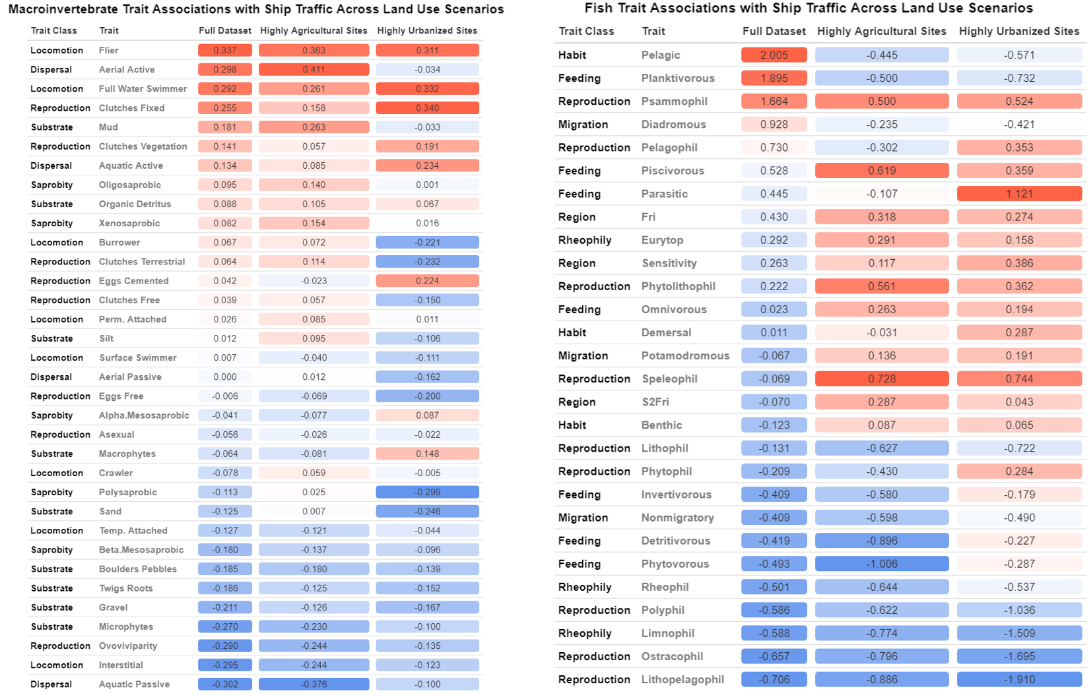

**Figure 2.** Fish and macroinvertebrate trait relationships with ship traffic across different land use scenarios. Trait scores associated with the environmental axis of heightened ship traffic in the RLQ analysis are shown in the ‘Full Dataset’ column, and are the values shown in the ordination of Figures 4 and 5. Columns two and three of each table show the trait associations with heightened ship traffic when the RLQ is re-run in highly agricultural sites (those with the top 25% of agricultural cover across the datasets) and in highly urbanized sites.

Figure 3.

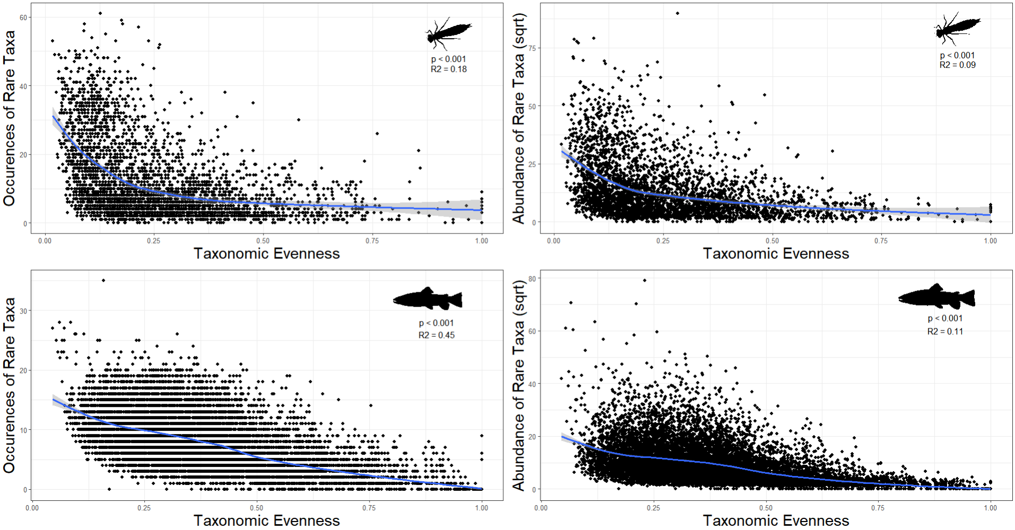

**Figure 3.** Relationships between taxonomic evenness and the abundance and occurrences of rare species in fish and macroinvertebrates. We defined a rare species as a species whose abundance accounting for less than 25% of the total community abundance (see Supplemental file 2 for details). Blue line represents the model regression and the area in grey surrounding the line represented the 95% confidence interval.